Game Design Document

Fill up the Following document

1. Write the title of your project.

Cyber Crime Investigation Game (name not decided yet ,though ,thought of examples like Cybox , Cyber heist etc. (not final name suggestions))

1. What is the goal of the game?

To educate indivisibles about the cybercrimes happening around them

1. Write a brief story of your game?

There are 2 seasons in my game having episodes and scenes…

The 1st one is about the cybercrime happening with oneself

And the 2nd one is about a bank heist which caused a damage of 45 million dollars

1. Which are the playing characters of this game?

* Playing characters are the ones which respond to the user based on the input from the user
* Cars, monkeys, dinos, wizards etc, are the playing characters in the game.

|  |  |  |
| --- | --- | --- |
| Number | Character Name | What can this character do? |
| 1 | Season 1:You | Has to safeguard his digital life |
| 2 | Season 2: Secret Service Officer | Has to investigate and secure the bank’s vulnerability. |
| 3 |  |  |
| 4 |  |  |
| 5 |  |  |
| 6 |  |  |
| 7 |  |  |
| 8 |  |  |

1. Which are the Non Playing Characters of this game?

* Non Playing characters are the ones which don't have an action or a behaviour when the user interacts with the game.
* Hurdles, stones, bananas, coins, etc are non playing characters in the game.

|  |  |  |
| --- | --- | --- |
| Number | Character Name | What can this character do? |
| 1 | Hacker | Hack into:  Your Gmail your social media  Online Shopping your bank account(net banking)  devices |
| 2 | A group of hackers | 1.Card processors breaches  2.program credit cards with different pins  3.recruit money mules  4.Give them the credit card data  5. carry out money laundering |
| 3 |  |  |
| 4 |  |  |
| 5 |  |  |
| 6 |  |  |
| 7 |  |  |
| 8 |  |  |

Draw your imagination of this game. What does this game look like?

* Draw the game either on your computer or on paper,
* Add images of scenes of the game to show each of the playing and non-playing characters at least once.

The below screen would be telling the Insights about the season and the episodes

The next image is the playing screen of the game

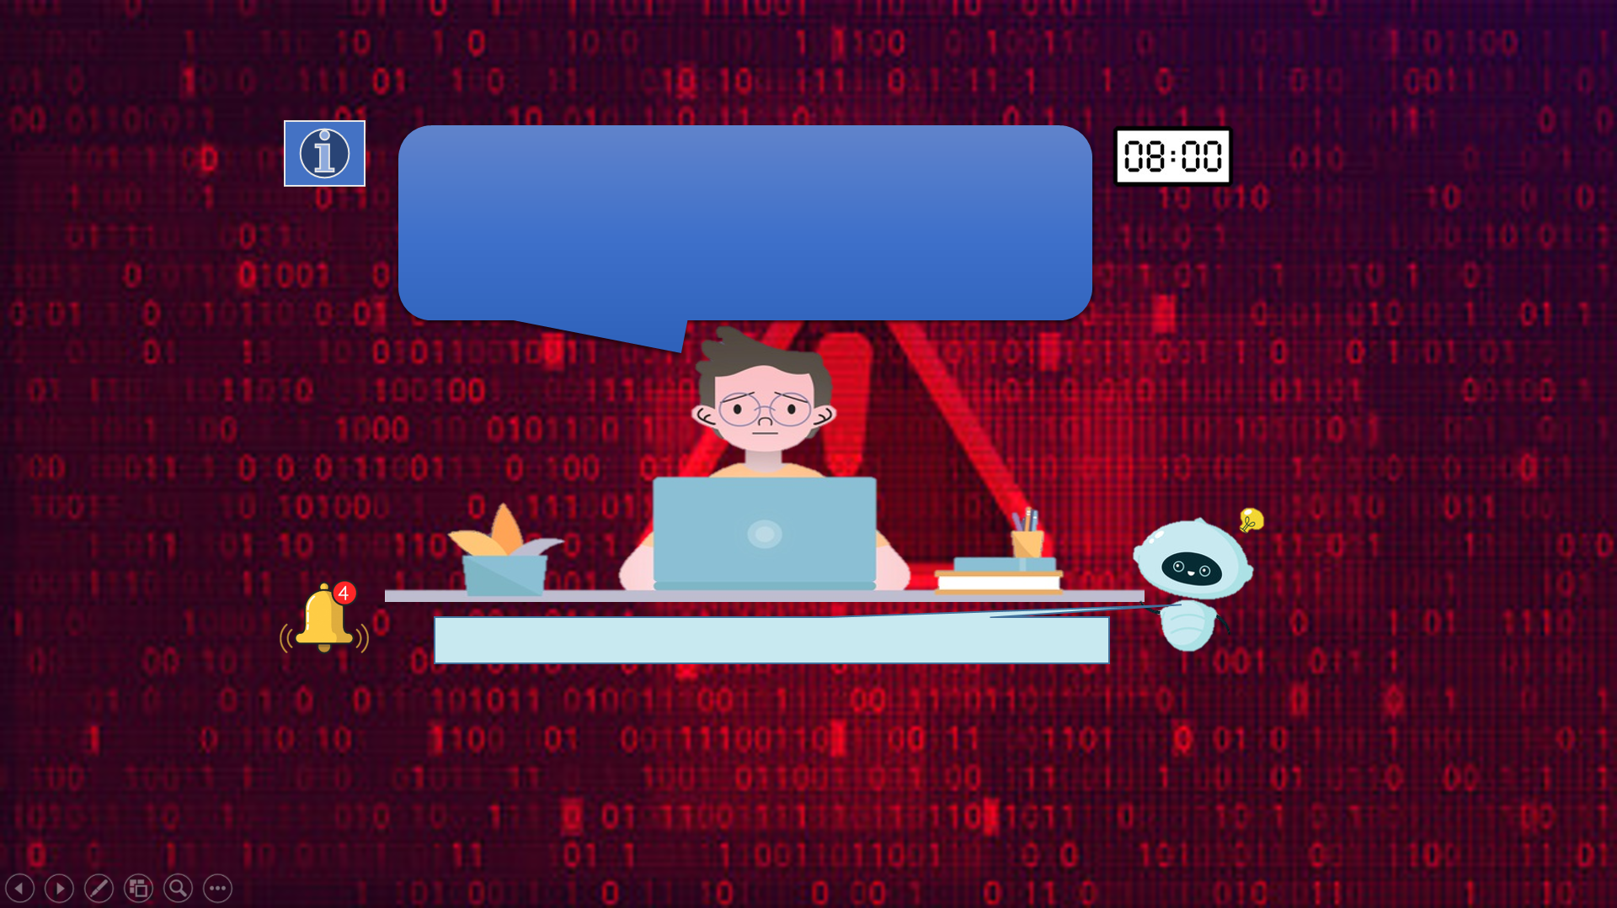

The notification and hint bot prompts.

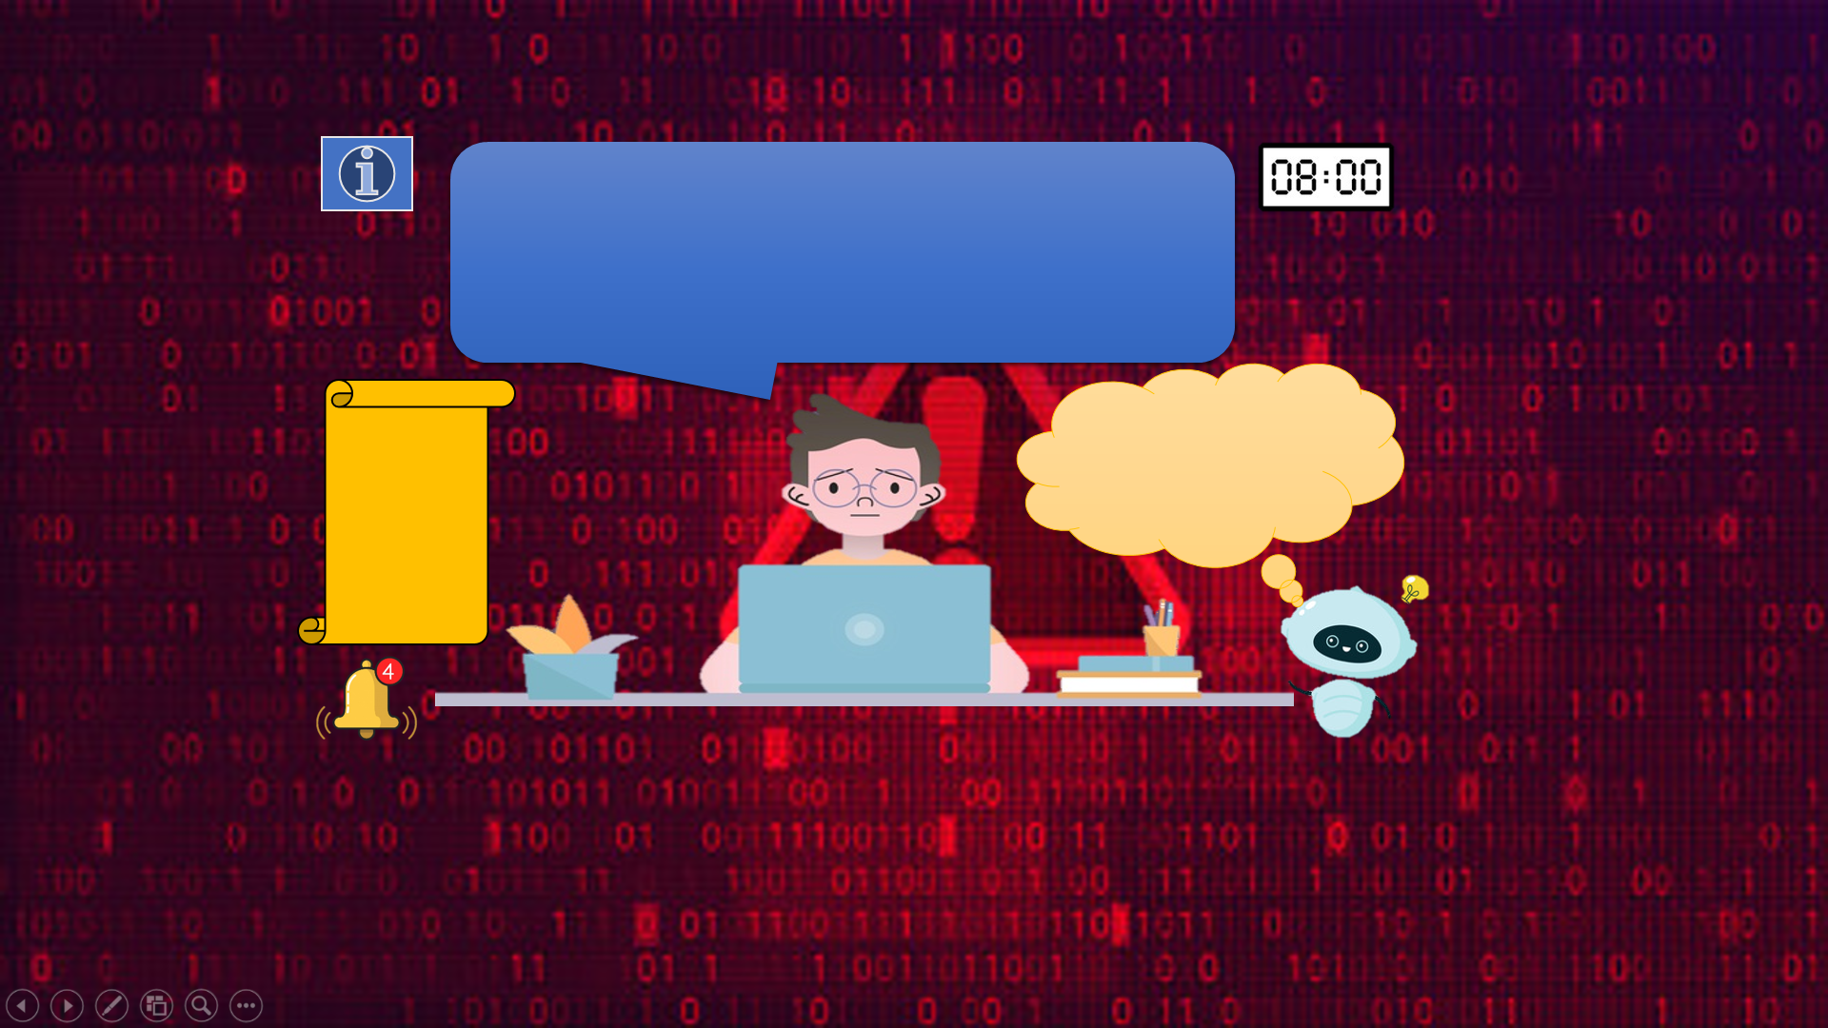

How do you plan to make your game engaging?

The game will remain engaging as the user will have time bomb before that he has to secure his current threat or else his time will be reduced and the hacker will do the next damage.